**Annual Licence Fees**

**TBMaster licence**

**Primary software licence**  **£700.00 Per location/Branch**

**Secondary machines**  **£300.00**

**Handheld Licence**  **£300.00**

**All licences bought with a new device can be** **subject to a discount of 20% if taken out for 2 years or more**

All Prices are excluding VAT

**Handheld Units** Prices includes a 4 year warranty

**Purchase Price (Plus 1st Year’s, or part thereof,**

**Handheld Licence Fee at £25/month)**

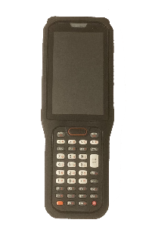

RT40

£1,100.00

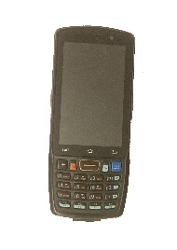 DT40

£900.00

Prices includes a 4 year warranty